END OF THE ROUND: Once the last cow is taken from the box, the game continues until a farmer takes the last herd. Once it is done, the round is over. Each farmer counts the numbers of ﬂies in his cowshed and add the result to the number of the previous rounds. He then takes the tokens corresponding to his score.

NEXT ROUND: A game of MOW is played over several rounds. The ﬁrst farmer to play is the one who ended the last round by taking the herd.

END OF THE GAME: As soon as a farmer has accumulated 100 ﬂies, the game ends. The winner is the farmer with the fewest ﬂies.

HEAD TO HEAD for 2 farmers:
This is played with three separate herds instead of one, laid out in three lines, one below another. From top to bottom, the herds are numbered: herd 1, herd 2 and herd 3.
The players cannot choose where to place their tiles: the herds must be played alternately. At the beginning of each round, the ARROW is placed at the center of the table, between the two farmers. The tip indicates in which order the herd must be played (at ﬁrst, 1 → 3).
Farmer A starts the herd number 1. Then, farmer B starts the herd number 2, below the ﬁrst one. Then farmer A starts the herd number
3. Since there is no herd number 4, farmer B continues with the ﬁrst herd, etc.
A farmer who plays a special cow with 5 ﬂies can, if he wishes, change the direction of play, downwards or upwards.
When a farmer cannot or does not want to add a cow, he takes the herd he was supposed to complete, and starts a new herd in its place without affecting the other two. When the deck is empty and one of the farmers takes one of the three herds, the round ends. Neither farmer collects points for the two remaining herds. All the other rules stay the same.
Translation: Cécile Migeon
Bruno Cathala Bony

7+ 2>5 15’

SUMMARY: The farmers round up cows and form them into herds ready to be brought into the cowshed. However some cows are infested with ﬂies and no farmer really wants to be near those…
THE AIM: To have the fewest ﬂies in your cowshed at the end of
the game.

The game contains:
48 Cow tiles, for a total of 74 ﬂies:
15 cows, numbered from 1 to 15, without any ﬂies 13 cows, numbered from 2 to 14, with 1 ﬂy each
11 cows, numbered from 3 to 13, with 2 ﬂies each
3 cows numbered 7, 8 and 9 with three ﬂies each 6 special cows with a super power… and ﬁve ﬂies! 1 arrow tile
8 big square-shaped tokens worth 50 ﬂies each
7 small square-shaped tokens worth 10 ﬂies each 30 big round-shaped tokens worth 5 ﬂies each 26 little round-shaped tokens worth 1 ﬂy each

1 5 10 50

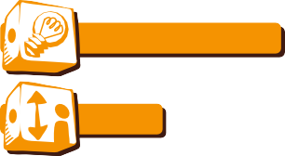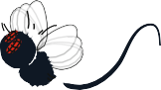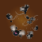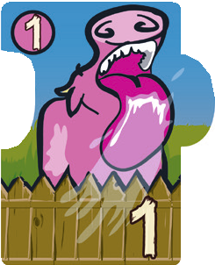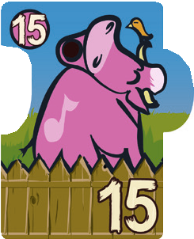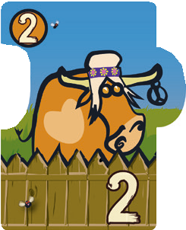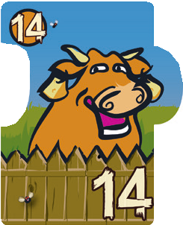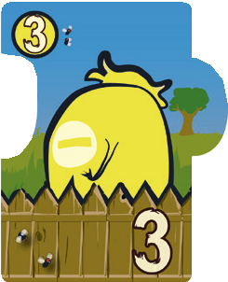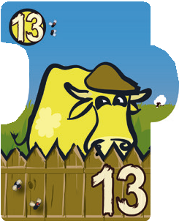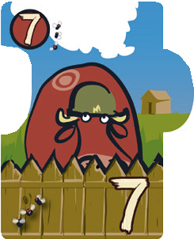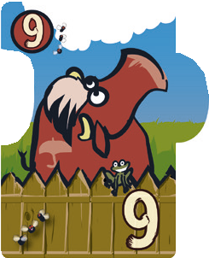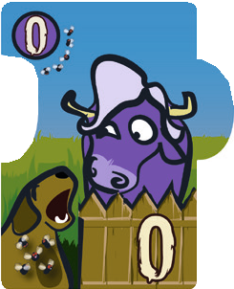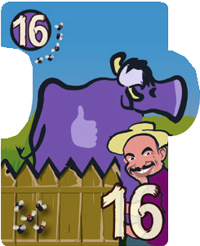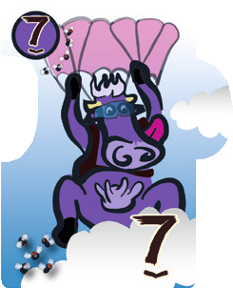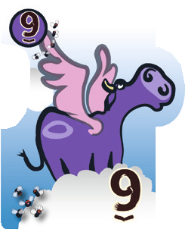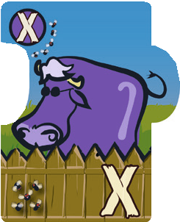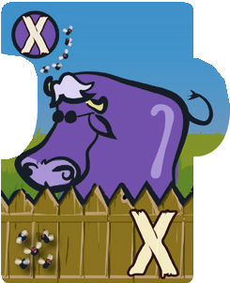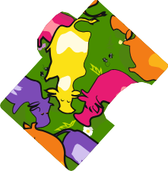

4 1

HOW TO READ A COW TILE: This version of MOW is adapted
so blind and visually impaired people can play.

Each number is written in Braille on the top left corner of the tile.

Each number is also written with very contrasted colors on the bottom right of the tile. It is also tactile, thanks to a thick layer of varnish.

The number of ﬂies is indicated with embossed dots on the bottom left. 1 dot means 1 ﬂy, 5 dots means 5 ﬂies.

HOW TO PLAY: Shuffle the tiles face down, then put them back in the box (still face down).
Each farmer is dealt ﬁve cow tiles. He must keep them in his hand and not show them to the other players. The youngest farmer places the arrow tile in front of him pointing towards his left-hand neighbor. He plays a ﬁrst tile from his hand in front of him, face up, to start a new herd of cows. Then each farmer in turn adds a cow. To do so, one simple rule must be followed:
- EITHER the tile has a LOWER number than those already played and must be placed at the very left end of the herd.
- OR the tile has a GREATER number than those already played and must be placed at the very right end of the herd. Once his turn is over, the farmer takes a new tile from the box.

For example: if the tiles 7, 8 and 11 are on the table, you can only play a tile with a number smaller than 7 or higher than 11.

BRING THE HERD INTO THE COWSHED: A farmer who CANNOT
or DOES NOT WANT to add a cow to the line, takes all the tiles in the herd and places them face down in his cowshed. Then, he starts a new herd.

Tiles with 5 flies are special tiles:
Blocking cow (numbers 0 and 16)
Play this cow to block off one end of the line.

Flying cows (numbers 7 and 9) Play this cow on another cow with the same number.

Blind cow (an X is embossed) Insert this cow into the line in place of a missing number. For example, it can take the place of the 6, 7 or 8 between the 5 and the 9. It can be placed between two following numbers.

Note! A farmer who plays a special cow can, if he wishes, change the direction of play. In this case, he takes the arrow tile, pointing it left or right as he prefers. The game continues in the direction shown by the arrow.

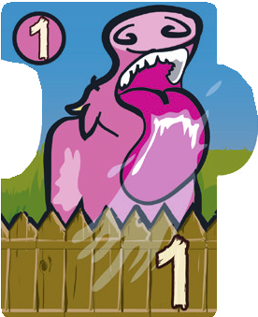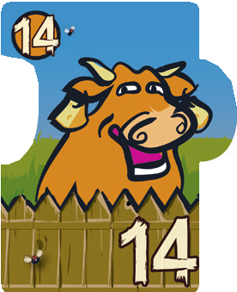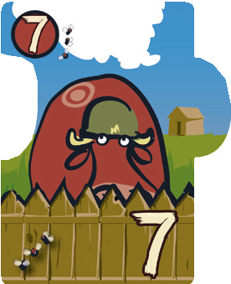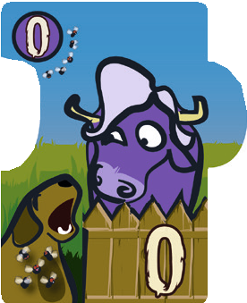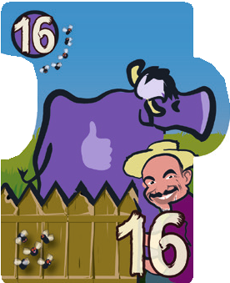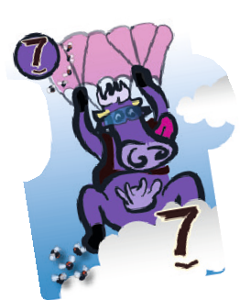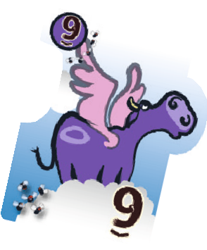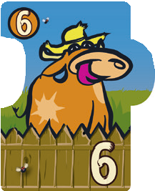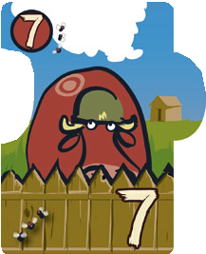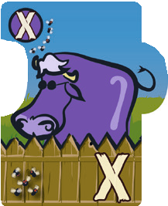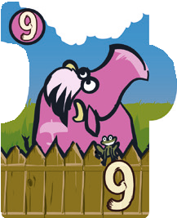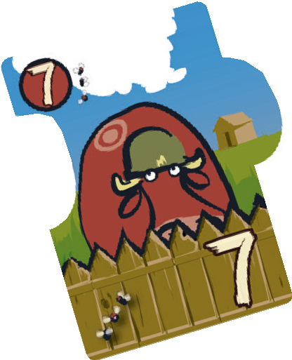

2 3

